Milestone II – Multi-Agent Workflow
DeliFin AI – AI-Powered Finance Platform

1. System Overview
DeliFin AI uses a fixed pipeline, orchestrator-coordinated multi-agent architecture. Every user message passes through a 4-stage pipeline managed by a central orchestrator.js module. Agents execute sequentially, each agent’s output feeding into the next.
Pipeline flow:
User Input → Planning Agent → Data Fetcher Agent → Analyst Agent → Disclaimer Agent → Final Response

2. Architecture Diagram
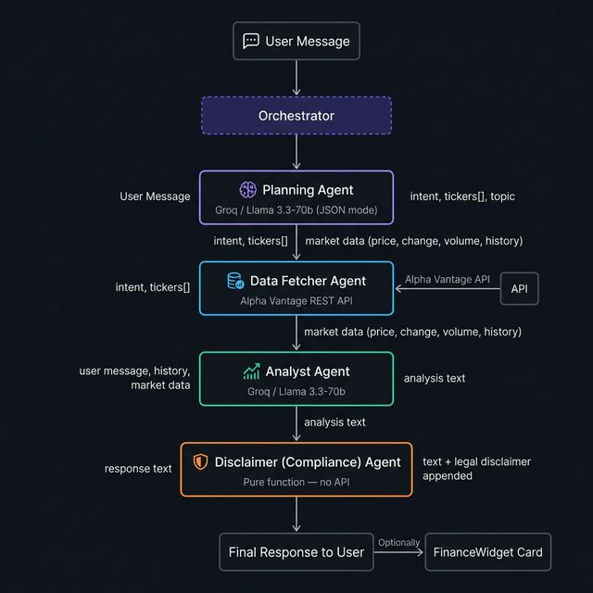

3. Agent Descriptions

3.1 Planning Agent
Role | Intent classifier and pipeline router
Model | Groq / Llama 3.3-70b (JSON mode)
Input | Raw user message (string)
Output | { intent, tickers[], topic, agents_needed[] }
Classifies queries into: general, stock_quote, historical_data, or portfolio_plan. Extracts ticker symbols. On failure, falls back to a general intent plan.

3.2 Data Fetcher Agent
Role | Real-time and historical market data retrieval
API | Alpha Vantage (GLOBAL_QUOTE, TIME_SERIES_MONTHLY)
Input | intent (string), tickers[] (array of symbols)
Output | Array of data objects { type, symbol, price, change, ... }
Only invoked for stock_quote or historical_data intents. Per-ticker errors are caught individually; pipeline continues without data on total failure.

3.3 Analyst Agent
Role | Financial analysis and educational content generation
Model | Groq / Llama 3.3-70b
Input | User message, conversation history, optional market data
Output | Human-readable analysis text (string)
Injects live market data as context so the model can cite real figures. Maintains full conversation history for multi-turn memory. Instructed to omit disclaimers (handled downstream).

3.4 Disclaimer (Compliance) Agent
Role | Legal compliance and liability protection
API | None — pure function, no network call
Input | Assembled response text (string)
Output | Text with standardized legal disclaimer appended
Deterministic, stateless function appending a fixed disclaimer to every response. Cannot fail.

4. Coordination & Communication
The orchestrator (orchestrator.js) is the single coordination point. Agents communicate via function return values — no shared state or message queues. A status callback (onStatusUpdate) is emitted before each agent runs, keeping the UI sidebar and header icons synchronized in real time.

5. Failure Handling
Agent | Failure Mode / Handling
Planning Agent | API error or bad JSON → fallback to general intent
Data Fetcher | Network error or bad ticker → skip ticker, continue
Analyst Agent | API error → return error string, continue to disclaimer
Disclaimer Agent | Cannot fail (pure function)

6. Technology Summary
Framework | React 18 + Vite
Language AI | Groq API — Llama 3.3-70b-versatile
Market Data API | Alpha Vantage REST API (free tier, CORS-compatible)
Coordination | Custom orchestrator module (orchestrator.js)
Styling | Vanilla CSS with CSS custom properties

